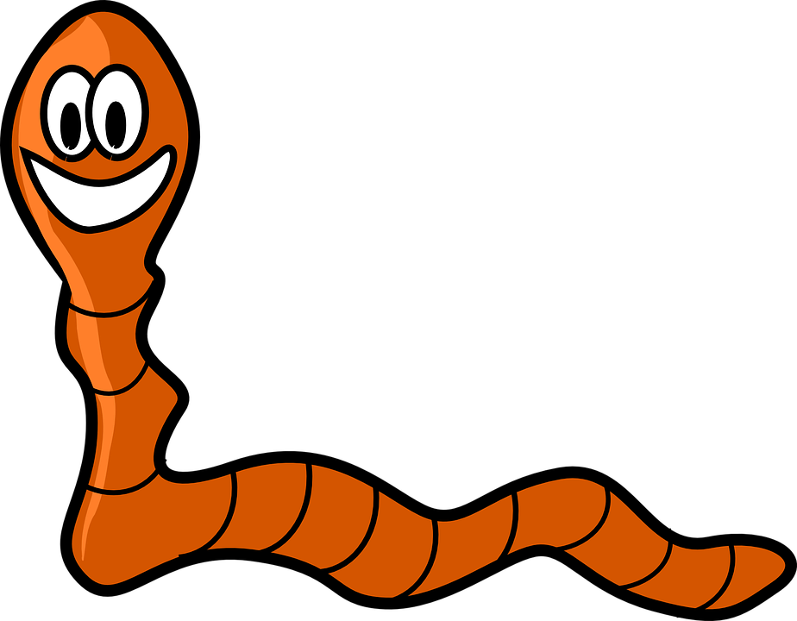
Living Earthworm Stimulus & Response Lab

Question we are answering today: What behaviors will an earthworm show in response to different stimuli? We will use the following stimuli: light, moisture, & vinegar.

Hypothesis: How will an earthworm respond to each stimulus?
Light: ________________________________________________________________ _____________________________________________________________________
Moisture: ______________________________________________________________ ______________________________________________________________________
Vinegar: _______________________________________________________________ ______________________________________________________________________

Background: Un-Stimulated Behavior

- Obtain one earthworm for you and your partner(s).
- Earthworms, like flatworms, are hermaphrodites. What does this mean that they can do?
______________________________________________________________________________________________________________________________________
- Since worms are hermaphrodites, give your worm a gender-neutral name: ______________________
- Observe the worm’s behavior for 30 seconds. When the worm is left alone, what behaviors does it exhibit? How does it spend its time?
_________________________________________________________________________________________________________________________________________________________________________________________________________
- In the box below, sketch your earthworm in scientific detail. Label the mouth, anus, and prostomium.
Our earthworm:

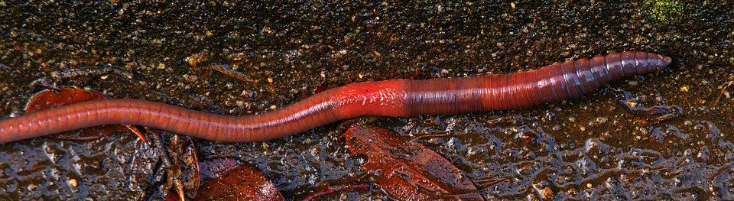
- Locate the thickening of the earthworm's body around the 30th segment This swelling is called the clitellum. Draw and label the clitellum on your drawing on pg. 1.
clitellum

- The clitellum is located closer toward the anterior end of the worm. Label the anterior end of the worm in your drawing. Also label the posterior end of the worm.
- Anterior means: _____________________
- Posterior means: ____________________
- On the ventral side of the earthworm are small bristles called setae. All annelids have setae of some form.

What does ventral mean? __________________________

Attempt to view the setae with a magnifying glass. You can also feel them by running your fingers along the ventral side of the worm.

Could you see or feel the bristles? ____________________________________

- On the ventral side, note the tiny “pimple-like” openings around the 14th segment (right before the clitellum). These are the sperm, where sperm is exchanged between two mating worms. Draw and label the setae and the sperm ducts on your drawing on page 1.

Show your teacher the sperm ducts on your real earthworm and obtain their initials: ________

- Study the earthworm's head. Does it appear to have any sense organs, such as eyes, ears, nose, or mouth? If yes, which ones?
______________________________________________________________________________________________________________________________________

- Check the boxes of which stimuli you think your worm will be able to respond to:

◻ Light? ◻ Odor? ◻ Sound? ◻ Taste? ◻ Touch?

- The dorsal side is darker. Which side does the worm prefer to keep facing up (dorsal or ventral)?
______________________________________________________________________________________________________________________________________
- Roll the worm over on to the side opposite your answer to #12. What does the worm do as a response when you flip it over?
______________________________________________________________________________________________________________________________________

Stimulated Behavior: using the data table on page 4, record your results for each test.

Reaction to Light: Revisit your hypothesis. Do you think the worm will move toward or away from light? Why? Don’t just re-write your hypothesis; explain your hypothesis!
______________________________________________________________________ ____________________________________________________________________________________________________________________________________________
Your tasks:
- Put the worm in the middle of the dissecting pan and cover ½ of the pan with the dark piece of construction paper. Watch the worm for 3-4 minutes.
- Record the worm’s behavior in the table on page 4.

Reaction to Moisture: Revisit your hypothesis. Do you think the worm will move toward or away from moisture? Why? Don’t just re-write the hypothesis; explain it!
______________________________________________________________________ ____________________________________________________________________________________________________________________________________________
Your tasks:
- Remove the piece of construction paper from the last section.
- Cover ½ of the pan with a moist paper towel and the other ½ of the pan with a dry paper towel.
- Place the worm in the middle between the paper towels. Watch the worm from 3-4 minutes.
- Record the worm’s behavior in the table on page 4.

Reaction to Vinegar: Revisit your hypothesis. Do you think the worm will move toward or away from vinegar? Why? Don’t just re-write your hypothesis; explain it!
______________________________________________________________________ ______________________________________________________________________ ______________________________________________________________________

Your tasks:
- Remove the dry towel and recover the pan with the wet paper towel.
- Obtain 2 cotton swabs and dip one in water and one in vinegar (KEEP TRACK OF WHICH IS WHICH!).
- Without touching the earthworm with the swabs, hold the water swab in front of the anterior end of the earthworm. Do the same with the vinegar swab. How does it respond to the vinegar swab? Write your answer to this question in the table on pg. 4.

Stimulated Behavior Data
Test | Observations
Reaction to light | In this test, the stimulus was: ____________________  Our earthworm’s response to the stimulus was: _____________________________________________ _____________________________________________ _____________________________________________
Response to moisture | In this test, the stimulus was: ____________________  Our earthworm’s response to the stimulus was: _____________________________________________ _____________________________________________ _____________________________________________
Response to vinegar | In this test, the stimulus was: ____________________  Our earthworm’s response to the stimulus was: _____________________________________________ _____________________________________________ _____________________________________________

Analysis Question:

Why did the worm respond to each stimulus the way it did? In other words, what is the PURPOSE of each response?

- Light: ______________________________________________________________ ______________________________________________________________________________________________________________________________________
- Moisture: ___________________________________________________________ ______________________________________________________________________________________________________________________________________
- Vinegar: ____________________________________________________________ ______________________________________________________________________________________________________________________________________

